**Conclusions**

# **Costs**

**Material Costs**

The budget given by Imperial College is £500, the total costs spent by the group is £257.44. Most of the costs are spent on the internal boards and camera module of our product, some costs are used on the external packing and demonstration. The manufacturing cost for one DARE device is 34,07 + 19,79 + 25,79 + 7 =86,65£.

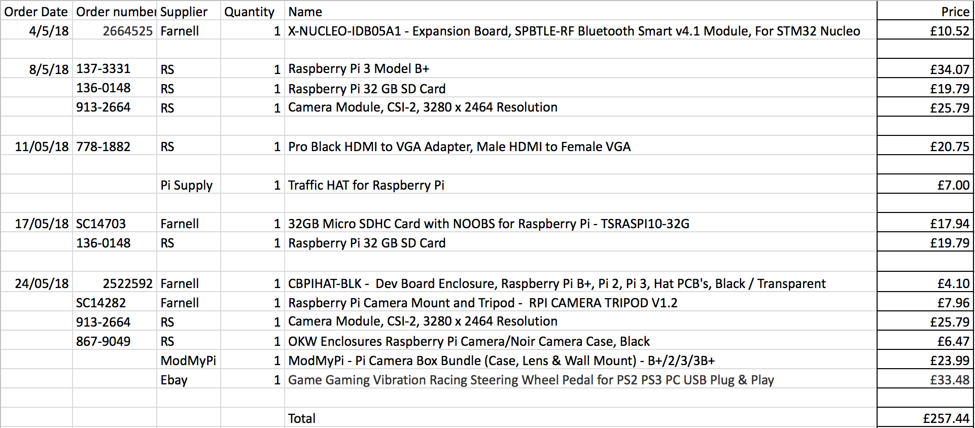

## **Travel Costs**

The travel costs are the railway tickets for a team of six members to visit the ARM company in Cambridge on the 15th of June of 2018.

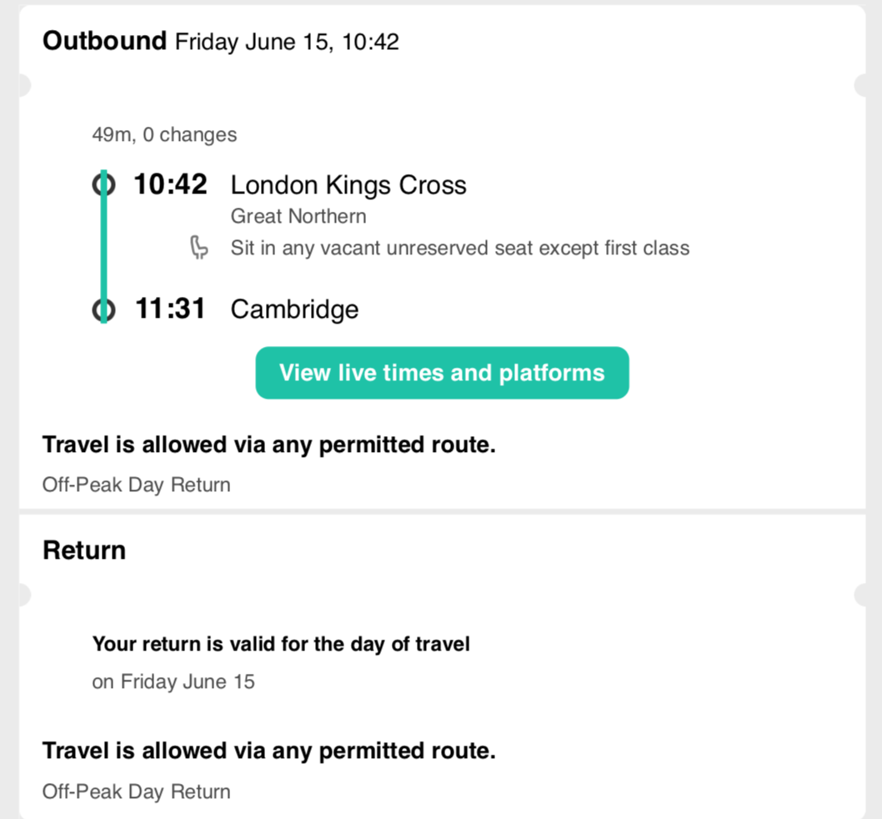



## **Total Costs**

Total cost = Material costs + travel costs = £257.44 + £153.90 = £411.34

1. **Ethical report**

The testing and utilisation of our device touch upon various ethical concerns, which we are committed to tackle in order to protect users.

Testing

Drowsy drivers are a danger to other road users. Hence, for evident ethical reasons, we could not conduct experiments on the road in order to test our device. As a result, we have used the driving simulator located on the 10th floor of the EEE building for testing.

Users’ privacy and confidentiality

One of the most significant ethical concerns, and also a legal issue, is the protection of individuals’ privacy. Indeed, individuals have a right to choose which information they disclose to companies and which information they keep for themselves. This implies that ARM should not film users for their own purposes without users’ consent. It follows that ARM should neither store nor transfer any data regarding its users if these have not agreed to. As a result, we believe ARM should update its privacy policy to meet the high standards of the new European data protection law, known as the General Data Protection Regulation (GDPR). This new legislation will significantly strengthen customers’ privacy rights by governing how data is processed, stored, utilised and managed by companies.

Employees’ privacy and confidentiality

Technology enables companies to have a greater overview of their employees’ practices. For instance, some companies include clauses in employment contracts that grant them the authority to monitor the electronic activity of their staff. By doing this, some ethical violations become readily apparent, such as the infringement upon employees’ right to privacy. We believe that ARM should handle its employees’ privacy with the same ethical standards as with its customers’ privacy.

Other issues

Our device detects drowsiness by checking lighting pattern zones on the user’s face. Yet, this could potentially be an issue for users with a dark skin colour. Indeed, the device might not work as efficiently with these users as it would with users of lighter skin colour, thus creating discrimination between users and raising ethical concerns.

<http://smallbusiness.chron.com/effects-technology-work-ethics-18716.html>

1. **Sustainability**

The world is now facing significant environmental challenges, due to the increasing levels of waste and pollution. According to the UN Environment Assembly, 8.3 billion tons of plastic have been produced while only 9% of the plastic waste is recycled. Consequently, we believe that ARM should be committed to designing products with a low environmental impact. To achieve this, we added the SPI resin identification code “seven” for PLA material to help recyclers identify the material accurately and efficiently (see figure below). PLA can be recycled to monomer by thermal depolymerisation or hydrolysis. The monomer can be used to produce the raw PLA material stock without changing the original properties. Only four screws are used to assemble the case, simplifying the disassembly process and reducing the materials waste, which also aids the recycling process.

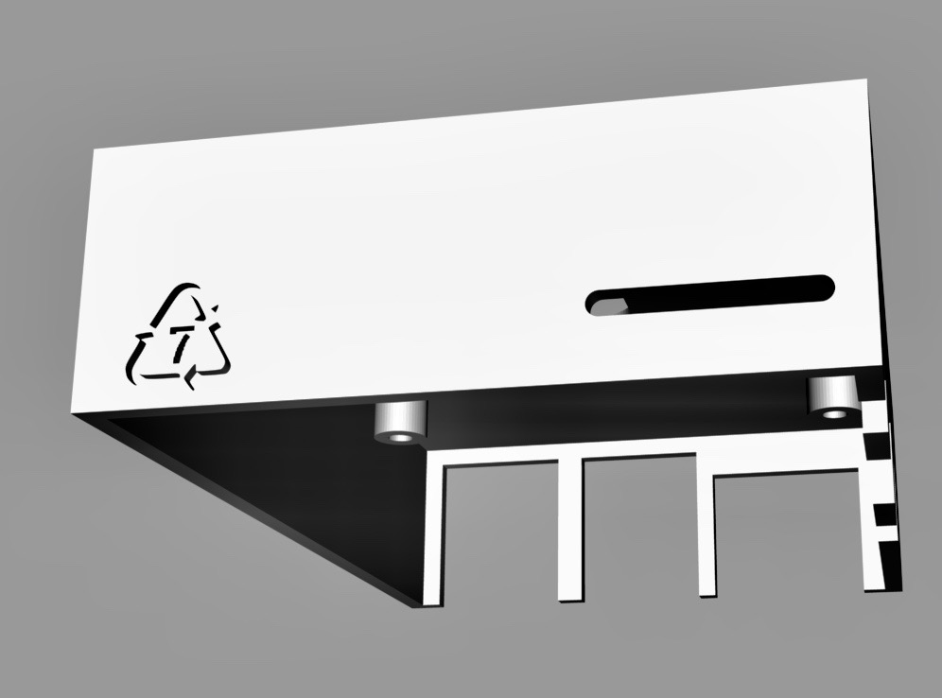

For future mass production, we would like to apply the ISO 14001 standard, which is an internationally recognised framework for setting up an environmental management system to improve resource efficiency, reduce waste and cut waste management costs. For instance, following the framework would minimise environmental impact across the product lifecycle and enhance the performance of the supply chain, as well as qualify, monitor and control the ongoing environmental impact of the manufacturing operation.

http://web.unep.org/environmentassembly/marine

http://web.unep.org/environmentassembly/marine

# **Future Work**

**Future upgrade**

The device may need further upgrade in the future in aspect of its detection algorithm when a new algorithm with better performance can be applied. The SSH enables the user to access the command line from another device such as Mac or PC but it still requires some programming experience. The team may further develop the app in the future, creating a user interface that is combined with the SSH tool so upgrade would be an one-click, automatic process. For current stage, the capability of connecting to Wi-Fi (hotspot) will guarantee this possibility.

There are several device optimization tasks need to be completed in the future:

* Monitor more drowsiness-related measures to better estimate the driver’s state, such as steering wheel movement, lane position, or heart rate.
* Build a pedestal that can fit any dashboard to mount the device on.
* Increase the number of songs available (create an interface with Spotify).
* Improve the face recognition algorithm (use active learning, computing power).
* Introduce calibration function during device startup, so that the threshold value can adjust depending on the user’s eyes and mouth size.
* Use a lighter OS (such as Raspbian Lite)

**Conclusion**

Generally speaking, the process speed of this project is suitable, the costs are moderate and there are not too many difficulties. Also, the split of work was appropriate, all the tasks completed perfectly by the team one week before the deadline. Overall, the project goes smooth and good team working through the whole time.